4
Software_Application_____
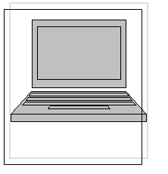
Chapter 10: Process Control Studio
Chapter 11: Process Control Studio Mobile Edition
In our project, we have implemented 2 types of software: one for the PC or laptop and the other for the PDA or PocketPC. We have called the former Process Control Studio and the latter Process Control Studio Mobile Edition. The software should enable an engineer to design a pictorial model of a process and monitor its performance as well as provide control actions.

